

MILESTONE 4 – DATA MODELING

Synopsis
Data modeling is a technique for organizing and documenting a system’s data. Data is viewed as a resource to be shared by as many processes as possible. As a result, data must be organized in a way that is flexible and adaptable to unanticipated business requirements – and that is the purpose of data modeling.
In this milestone you will first discover those entities in the system that are or might be described by data. With each entity we identify, we will define it in respect to the business. Then, we will construct a Context Data Model that graphically depicts each of the entities and the relationships they have with each other. Next, we will refine the context data model to include primary and foreign keys. The resulting model is called a Key-Based Data Model. Finally, we refine the key-based data model to include any hierarchies and attributes, and this model is referred to as the Fully Attributed Data Model.

Objectives
After completing this milestone, you should be able to:

- Understand and perform the techniques for entity discovery.
- Define each entity with respect to the business and complete an entity/definition matrix.
- Perform the necessary data modeling techniques to organize and document the data requirements for the proposed system.
- Construct the Context, Key-Based, and Fully Attributed data models.

Prerequisites
Before starting this milestone the following topics should be covered:
- Data modeling – Chapter 8
- Milestone 3 Solution

Assignment
In this assignment we will use our results of the previous milestones and transcripts of an interview between Kira Webster and Dotty Jones. The results of this activity will identify the business data requirements for the proposed system.
Exhibit 4.1 is a copy of the transcript of the interview. Refer to the transcript, sample forms, and results from Milestones 1-3 for the information necessary to complete the activities.

Activities
- Complete an Entity/Definition Matrix. Analyze each of the forms referenced by the user interview plus any comments made by Dotty Jones. Make assumptions where necessary.
- Prepare a Context Data Model.
- Prepare a Key-Based Data Model.
- Prepare a Fully Attributed Data Model. Add the data attributes for each entity.
Deliverable format and software to be used are according to your instructor’s specifications. Deliverables should be neatly packaged in a binder, separated with a tab divider labeled “Milestone 4”.

References:

Milestone 3 Solution
Provided by your instructor

Transcripts of Interview between Kira Webster and Dotty Jones and Accompanying Sample Forms and Report
Exhibits 4.1-4.5

Templates
See on-line learning center website for the textbook.

Deliverables:

Entity Definition Matrix: Due: __/__/__
Time:_______

Context Data Model: Due: __/__/__
Time:_______

Key-Based Data Model: Due: __/__/__
Time:_______

Fully Attributed Data Model: Due: __/__/__
Time:_______

ADVANCED OPTION

For the advanced option, assume that the proposed system must also track out-of-pocket medical expenses that have been turned in by the employee to be paid by the pre-tax medical contribution. Each expense must by tracked by date, employee, doctor, and description. Your instructor will specify additional system requirements for this part of the system. Modify your initial Entity Definition Matrix and Fully Attributed Data Model to be able to handle this system requirement.

Entity Definition Matrix: Due: __/__/__
Time:_______

Fully Attributed Data Model: Due: __/__/__
Time:_______

Milestone’s Point Value: _______

The following is a copy of the transcripts of an interview between Ms. Dotty Jones of A-1 Information Systems and Kira Webster, a systems analyst working on the project. The goal of this interview was to obtain sample forms used for processing employee information and to be able to ask questions about them in order to discover data entities of the business system.

Exhibit 4.1
Scene: Kira Webster is meeting with Dotty Jones, Manager of Employee Relations for A-1 Information Systems, at her office, room 1016, building 16. Ms. Webster scheduled the interview with Ms. Jones to obtain sample forms containing employee information.
Dotty: Good morning, Kira! How are you today?
Kira: Fine, thank you. I appreciate you taking time out of your busy schedule to meet with me.
Dotty: Since I am your main point of contact, Jack wanted me to be available as much as I could. You asked for some sample forms and reports. I have made copies of three of the forms we use, plus I have made a copy of a page out of our employee telephone listing.
Kira: Great! That will be a big help.
Dotty: The first form is the Employee Information Form [Exhibit 4.2]. Employees complete this form on their first day of employment. (Dotty hands the form to Kira.) It is mandatory that the employee completes the employee profile block, but the emergency contact information is optional.
Kira: Is the date the date the form was filled out or the official date of hire?
Dotty: It’s the official date of hire. It’s possible the employee may be ill on his or her first day of employment and not be able to come to work. Under those circumstances, when they do come to work and complete the form, that date reflects the day they were supposed to start to work. That hire date, by the way, is important to us. It is used in calculating vacation and sick days and other things.
Kira: Is this filled out by every employee, both salary and hourly?
Dotty: Salary, Hourly, and contract.
Kira: Contract?
Dotty: We have IT consultants, management consultants, and other kinds of employees on loan to us from the corporate office. We also have some independent consultants working as contract employees.
Kira: And they all fill out this form?
Dotty: We might need the emergency contact information on anyone. And we want everyone included in the employee directory.
Kira: Okay. Do you only want to record an employee’s middle initial?
Dotty: No. That’s a weakness of the form. We should be capturing an employee’s full name, including the middle name and any nicknames.
Kira: Okay. Can employees have more than two emergency contacts?
Dotty: Not with this form. But we have instances in which employees would like to enter a third contact.
Kira: I'll see what I can do about that.
Dotty: Next, we have the Employee United Way Contribution Form [Exhibit 4.3]. (Dotty hands the form to Kira.) New employees complete this form on their first day of employment. Current employees complete one of these forms every October for the following year. This gives them the opportunity to change their deduction or keep it the same.
Kira: It appears the top of the form is pre-typed?
Dotty: That’s true. A form for every employee is previously typed with name, ID number, department information, and supervisor name. The forms are then given to the supervisors for distribution. The managers ensure that the forms are completed and then return them back to us.
Kira: Is that true for new employees also?
Dotty: Yes, those forms are pre-typed also. We know ahead of time what department new employees will be working in, plus the manager they will be working for. That information is part of the job offer letter that is sent to prospective new employees. Once they accept the offer, by signing the letter and returning it, we assign them an employee ID. So when they report for the first day of work, we have already captured information about them. That’s why they only need to complete the remainder of the form during their orientation session.
Kira: I see. How are employee ID’s assigned?
Dotty: Sequentially. We never want to reuse an employee ID. That’s how we track employees. Even if they leave the company, they might one day come back. And, quite possibly we might owe them medical, pension, or retirement benefits. Does that make sense?
Kira: Yes it does. Are department ID's also assigned sequentially?
Dotty: No. Each of the digits in the department code means something. Each department also has a department name. For instance, 6410 is web services.
Kira: And each department has a manager?
Dotty: A given department could have multiple managers in a tiered arrangement. One person would supervise 5-7 people. Another person would supervise others. Both supervisors would report to a common supervisor. All in the same department.
Kira: Is this form used by all employees: salary, hourly, and contract?
Dotty: Not contract employees. Some of them are independent contractors. We don't want to bother them, and they don't count in our participation percentages.
Dotty: Okay. The next form is the Employee Misc. Deduction Form [Exhibit 4.4]. (Dotty hands the form to Kira.) New employees complete this form on their first day of employment. Current employees complete one whenever they want to change their miscellaneous deductions.
Kira: I see that various deductions are based on monthly, yearly, or per pay period deductions.
Dotty: That's right. Some employees are paid weekly, others bi-monthly, and a few monthly. We just enter the information as is and pass it on to payroll to figure out the impact on each pay check.
Kira: I bet you need to keep track of their prior deductions as well as their current deductions.
Dotty: You would win that bet. Whenever there is a question over deductions we need to know the current deduction options and the prior deduction options and the date when the employee requested the change.
Kira: Is this form used by all employees, even contract employees?
Dotty: Just salary and hourly. Contract employees have a special guest lot. And they are ineligible for life insurance or medical insurance.
Kira: Any other differences among the three types of employees?
Dotty: Well, you don't see it on these forms, but HR keeps track of pay rates in the system. Salary employees are paid based on an annual salary. Hourly employees are paid based on an hourly rate, plus we track a maximum hours per week that is scheduled for each hourly employee. Contract employees are paid on an hourly rate without a maximum. For contract employees we also track their permanent employer, either the home office or the employees themselves in the case of independents.
Dotty: Finally, we have a copy of part of a page from our Employee Telephone Listing.
[Exhibit 4.5]. (Dotty hands the form to Kira.) I believe it is pretty self-explanatory. You notice it includes employees from all our five sites, plus the building and room they are located in.
Kira: What is a Mail Stop?
Dotty: Think of it as a zip code for an in-house post office. Every employee’s mail is delivered to one of several centralized locations identified as mail stops. Usually it’s located in a little room or an area of an office. There the employees can go and retrieve their own mail. We have too many employees to provide mail delivery to each individual office or cubicle. It wouldn’t be very cost effective.
Kira: Can employees choose their mail stops?
Dotty: No, they are automatically assigned based on the room numbers.
Kira: So the room really says it all, doesn't it? That determines the mail stop, the building, and even the site.
Dotty: I guess you're right. If I know the building, then I know what site it must be.
Kira: Do employees ever share offices with other employees?
Dotty: Absolutely. But every employee has some office or room where he or she works.
Kira: Okay. That gives me plenty to work on. Dotty you have been a big help.
Exhibit 4.2
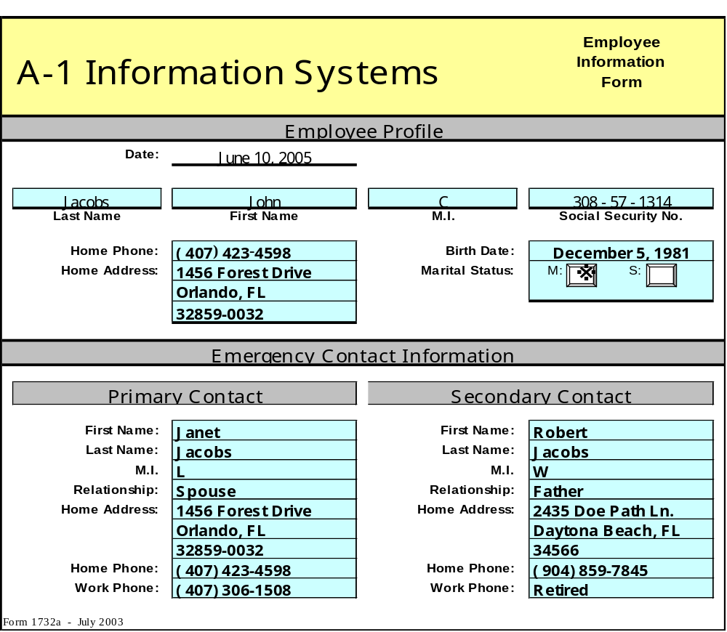
Exhibit 4.3

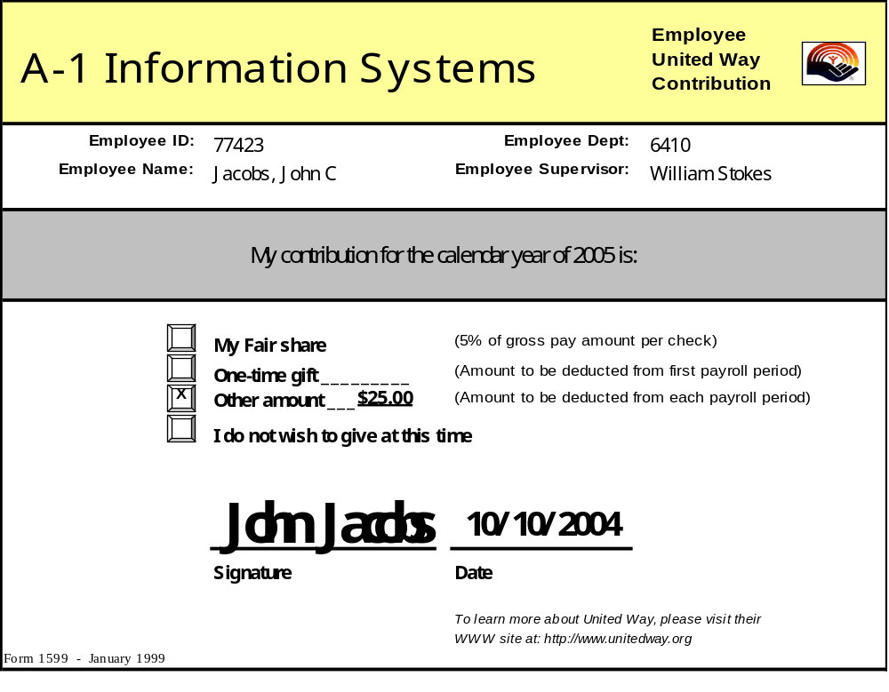

Exhibit 4.4

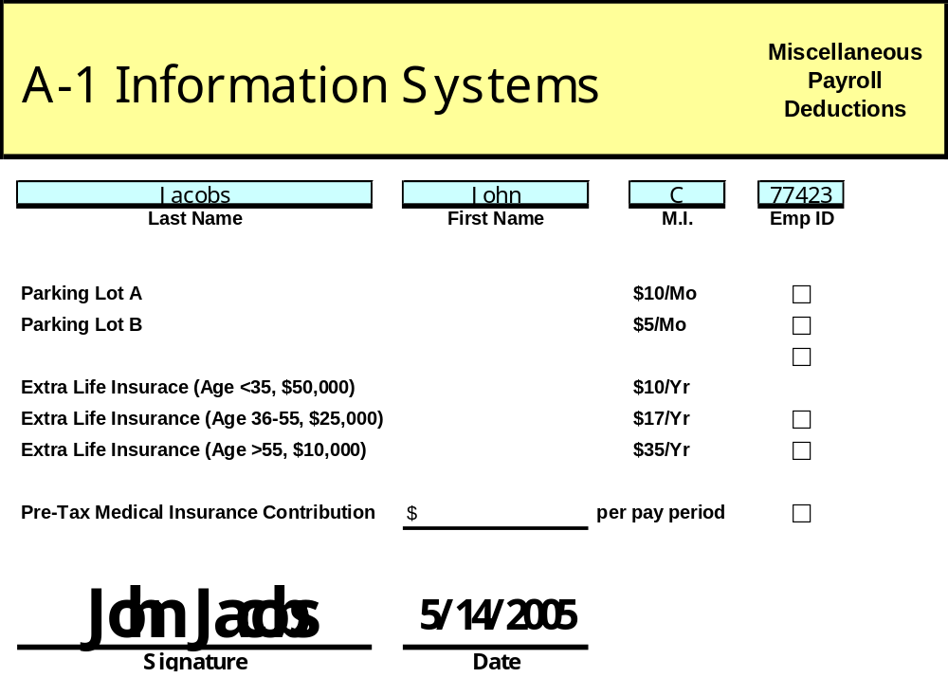

Exhibit 4.5

